## **Task-1**

Come up with a function, for an arbitrary collection of roles and users, given a user Id returns a list of ALL their subordinates (i.e.: including their subordinate's subordinates).

The employee file in S3 bucket which is read by the function getSubOrdinates in the helper_functions.pl

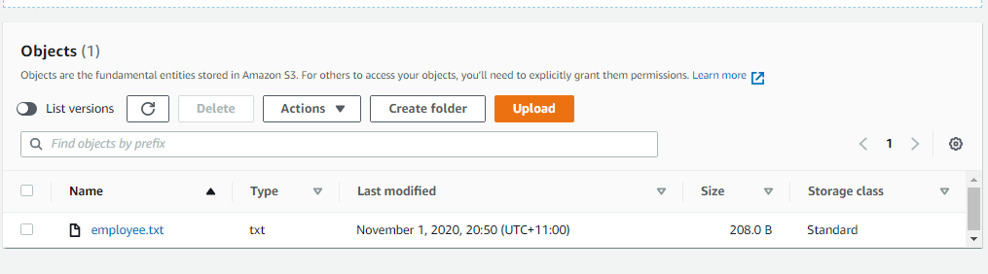

**The data in the file**

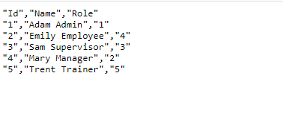

The output after running the function getSubOrdinates with name = ‘'Adam Admin'



The output after running the function getSubOrdinates with name = “Emily Employee”



**Task 2**

Create a functionality to add a new user and assign a role to him/her.

The writeUserToFile within the helper_functions write employee record into the employee file. (The employee record is copied to EC2 server to allow for append instead of overwriting the complete file since S3 files are immutable)

Employee data **BEFORE** write

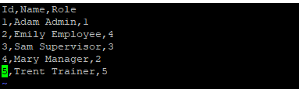

**Successful execution of helper_functions.pl** 

**It was run the following way**

if __name__ == "__main__": writeUserToFile('Simon', 'Jones','Employee', list([{'objRole': 'ObjRole1', 'id': '4', 'Name': 'Employee', 'Parent': '3'}]))

**Employee data after write**

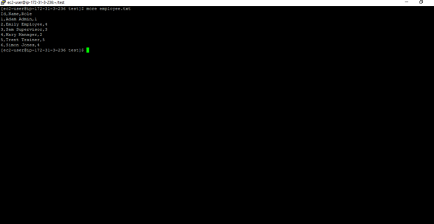

**Task 3.1**

Create text bar for search user and their hierarchy.  
P.S. Don’t worry about duplication.

**search_user.pl** is used to create the UI that helps to search user hierarchy

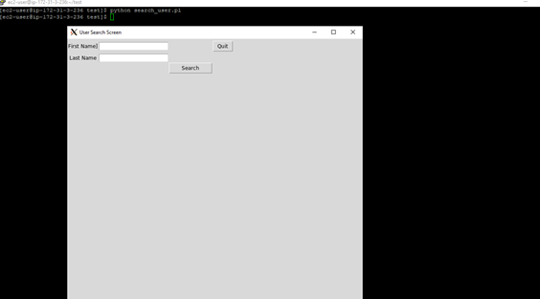

The button has a callback to getSubOrdinates which using the FullName retrieves the data from the employee file

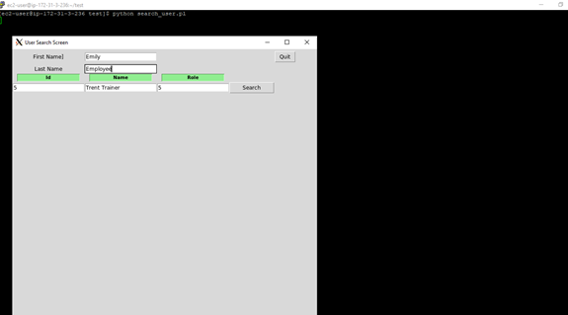

**When no user is found following warning is shown**

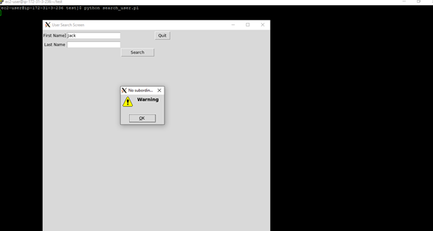

**Task 3.2**

**Adding user via UI**

**add_user.pl is executed to add user via UI.**

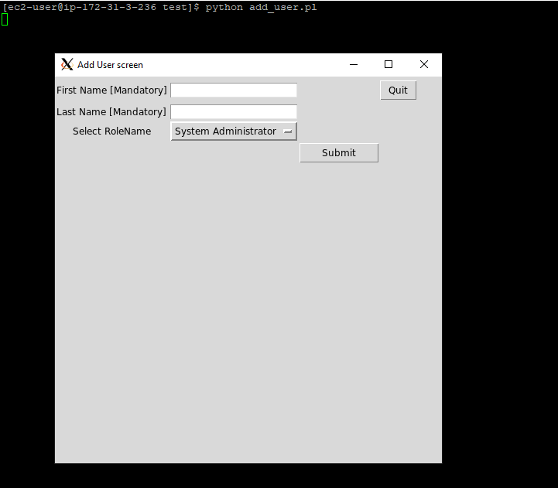

**The above screen has the dropdown list for Roles that is picked from the role file. Hence the UI user can only select from the roles that are available in the role file.**

**Once the user details are entered and the UI user clicks the ‘submit’ button, a popup window appears confirming the status of the entry submission**

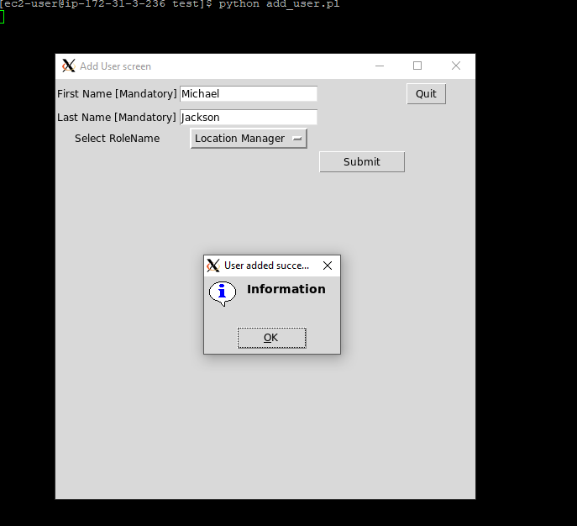

**In case the firstname or lastname is not entered a popup window with warning is displayed**

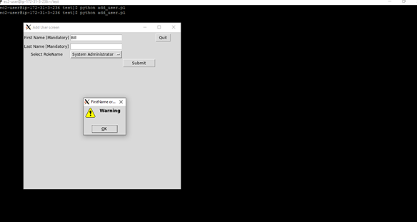

**Once user clicks OK, they can continue with entering the user data**

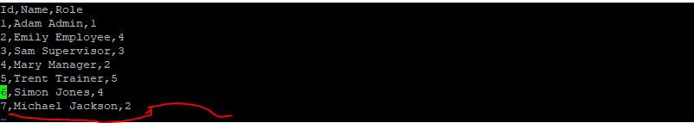

**Please find above the records from the employee file, where the last row is the one entered via the UI. Couple of points to be noted**

1. **The max(id) is picked from the existing employee file and incremented to assign to the new employee**
2. **The UI shows the RoleName field. Once the data is submitted, the roleId is picked from the rolefile and before inserting into the employee file.**

**Task 4:**

**All the jobs were run from the AWS EC2 Unix environment**

**Task 3**

1. Write a query to get average salary of “Content Creating Lead”

select cast(avg(salary)as numeric(18,2)) as average_salary,r.name as role_name from employee e

inner join role r on e.roleid = r.id

and r.name = 'Content Creating Lead'

group by r.name

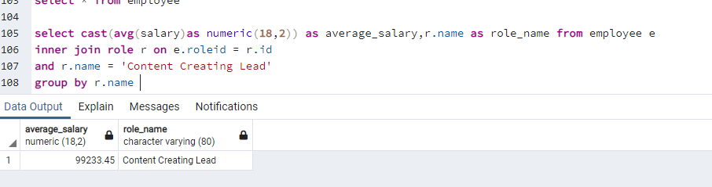

1. Write a query to get hierarchy for a person with role name E.g.   
   for id 1 the result would be:

select r.name as role_name, e.name as employee_name from employee e

inner join role r on e.roleid = r.id

where roleid >=1 order by roleid asc

